1. Given the provided data, what are three conclusions we can draw about Kickstarter campaigns.
   1. Theater projects had the highest success rates and specifically plays under the theater category had the highest success rate; this can be seen from stacked graph in the screen shot below.

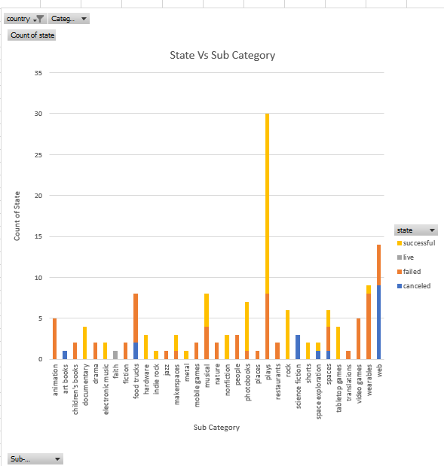

* 1. The success rate decreases the higher the goal, in contrary the failure rate decreases the higher the goal. This can be expressed in the data in the pivot table and pivot graph below.

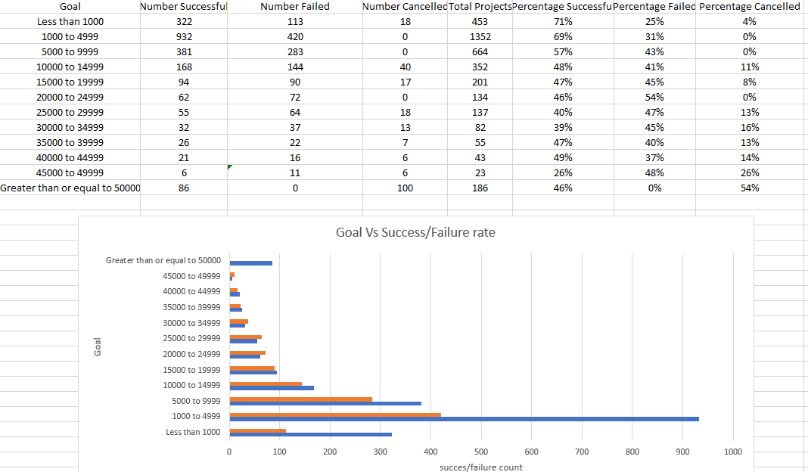

* 1. There is no meaningful relation between the number of cancellations and the goal of the project.

1. What are some limitations of this dataset?
   1. The number of backers of each project could affect the success, failure or cancellation rates of a campaign.
   2. The age of the campaign or how far back the data goes could be a limiting factor of the dataset current year is 2021 and the most current year for the data set is 217, a more recent data set would be more beneficial.
   3. The currency is not standardized throughout the entire campaign which skews the data when the matrix of measurement is not the same
2. What are some other possible tables and/or graphs that we could create?
   1. Backers count measured against success, failure or cancelation rates.
   2. Average donations measured against success, failure and cancellation rates.
   3. Time of the year (range of months) vs the success, failure and cancellation rates.